Homework # 8

Ruchi Panwar (rpanwar@kent.edu)

Advance Database

Fall 2015

Professor: Dr. Gregory S DeLozier

Nov 27, 2015

**MongoDB Todo App**

1. Items.py & app.py

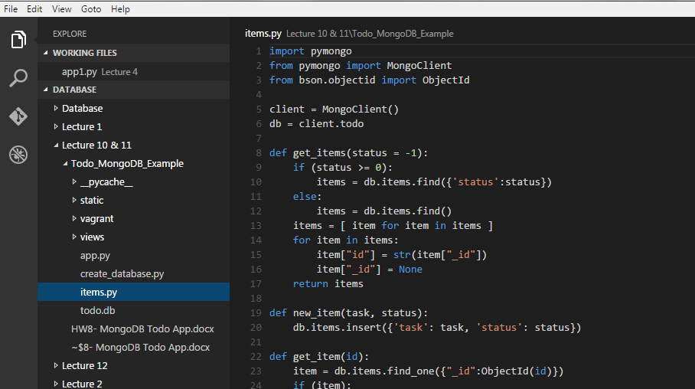

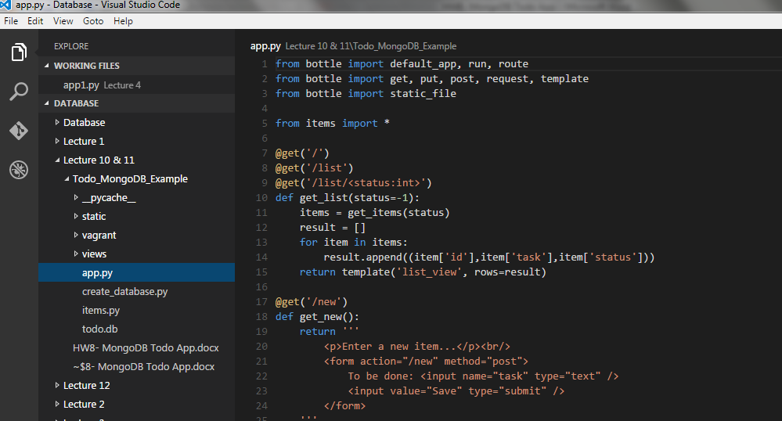

1. Code can be found on the below Github links (Lecture 10 & 11)

<https://github.com/rpanwar01/Database/tree/master/Lecture%2010%20%26%2011/Todo_MongoDB_Example>

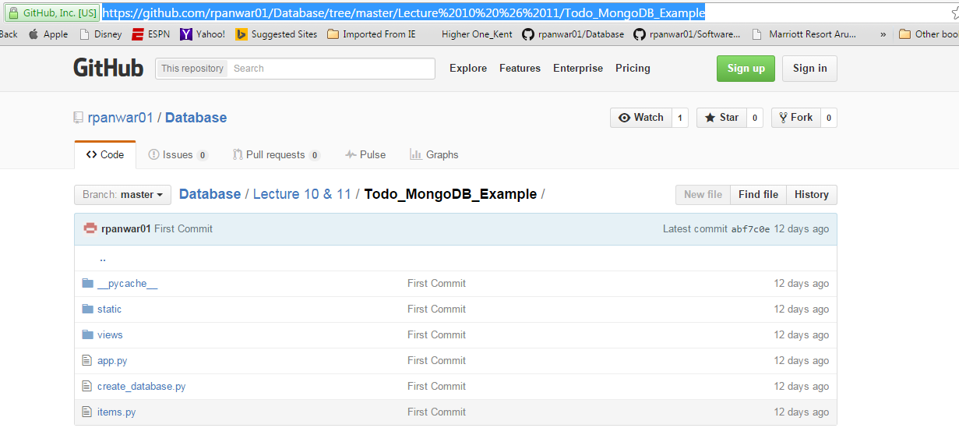

1. Execution and output of Todo app:

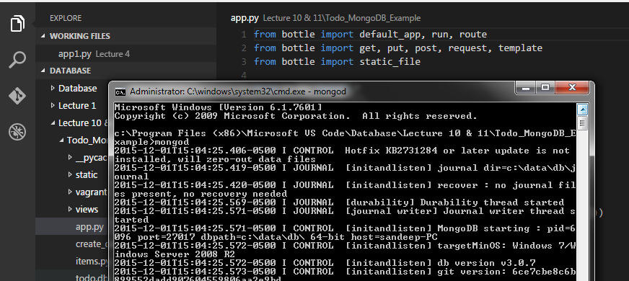

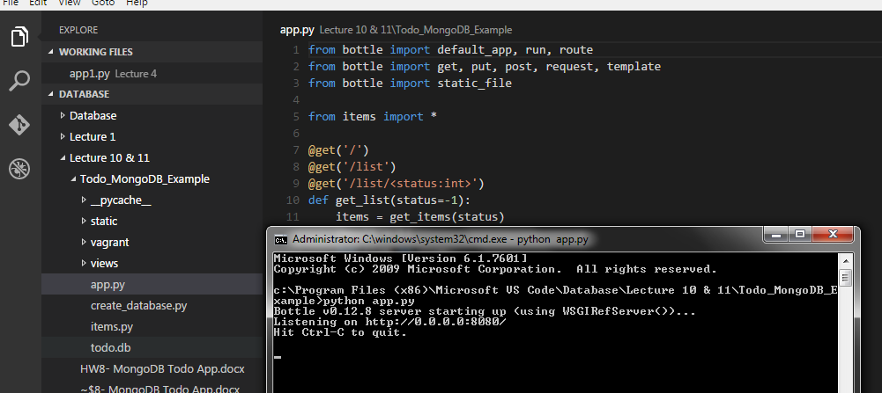

1. Home page of Todo app:

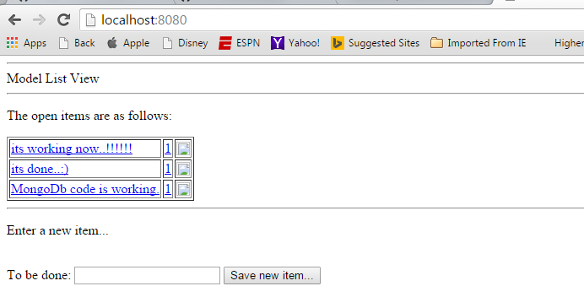

1. Edit an Item:

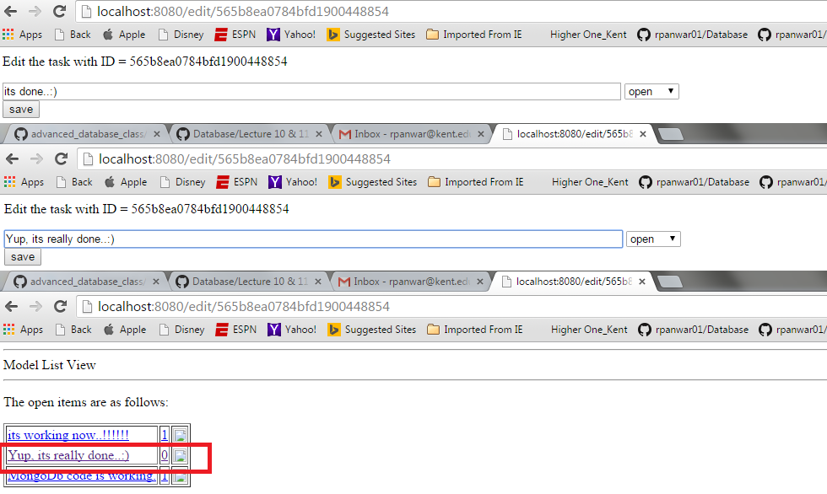

1. Add new Item:

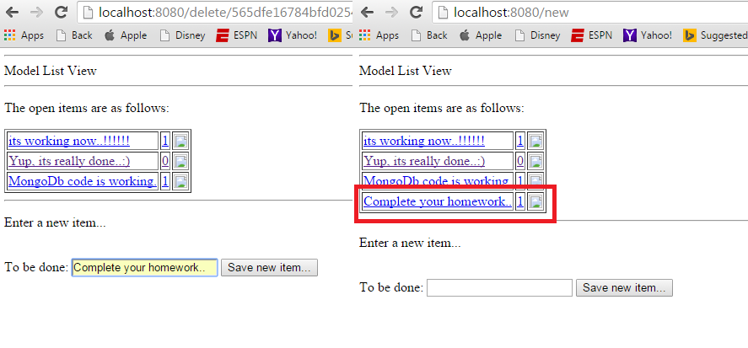

1. Delete an Item:

